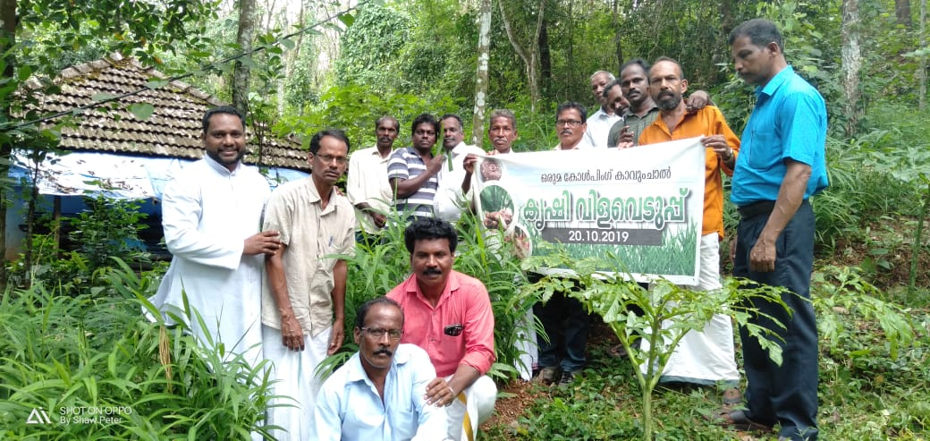
KAIROS

ANNUAL REPORT
2019-2020

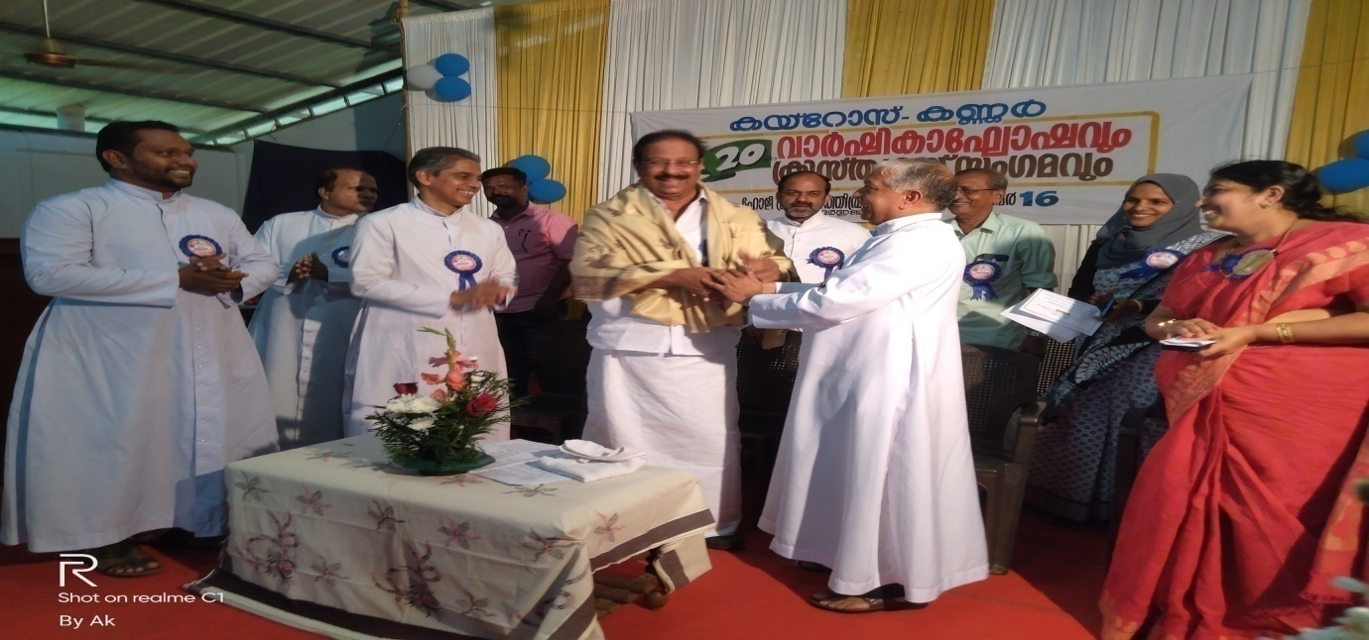

Introduction:
Kannur Association for Integrated Rural Organization and Support (KAIROS) was formed and registered under the Charitable Societies Registration Act in 1999. This is the official organ of the Mission Diocese of Kannur (The Diocese was erected in 1998 after bifurcating the Diocese of Calicut, consisting the northern Districts of the state – Kannur & Kasaragod) for the Socio-Economic Development of the poor and the marginalized. KAIROS is a non-profit non-government organization functioning for the development of people in rural areas and is spread in 65 villages of the operational Districts.

KAIROS is equipped with skillful staff members with adequate qualification and specific in house training and are committed to the cause of the poor and marginalized, especially women. Our hired hands include a project officer, a General coordinator three Regional Coordinators and 65 Village Coordinators. Besides, there is a squad of administrative staff to carry out the daily business of the office.

KAIROS is entrusted with the already existing People’s Organizations – the Women’s Organizations and Credit Unions – formed and facilitated by the undivided Diocese of Calicut. Later, KAIROS transformed these People’s Organizations into SHGs, and clustering the SHGs, Village Development Committees (VDCs) were formed. The women SHGs were bestowed with material and monetary resources. The organization is running successfully to continue its mission and its supporting role despite the withering resources. Rather than merely fulfilling the ever increasing needs of its target community, KAIROS has now shifted its focus on self sufficiency through entrepreneurship and empowerment. We are mobilizing funds through KSBCDC for facilitating the needs of our focused community. We have also made significant interventions in the planning and implementation of various projects in the development sector. KAIROS offers several consultation services and has become a part in conducting different assessments and studies for different government agencies. In the recent scenario of increased natural calamities and disaster proneness, we have begun to make interventions in the areas for disaster preparedness and mitigation trainings and activities to create a resilient community. At present, the operational area of KAIROS is divided into six regions in which there are 539 SHGs (Both men and women) 82 Kolping Units (formed and facilitated exclusively for catholic families) and 62 children’s groups (Balavedis). All these CBOs cover a total 28536 beneficiary families.

- 1.ASAKIRANAM
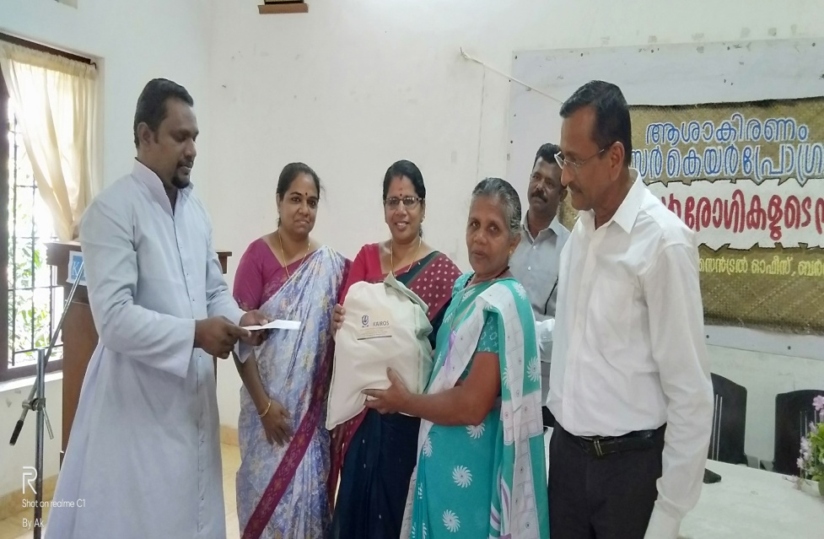
Ashakiranam is a cancer campaign program supported by Caritas India. It helps to identify the causes and consequences of cancer. The awareness of the sickness can be helpful to improve the approach to the affected patients, alter the lifestyle and to make early detection of cancer to provide effective treatment. Different types of awareness classes, preventive programs, cancer detection camps and patient support programs are conducted to rebuild a healthy family and society. 21 cancer awareness classes were conducted in Panchayat level during the year under this program. The sessions were handled by experts like, Doctors, Health inspectors and wellness consultants. 1534 people participated in different sessions. A cancer awareness street play was conducted in Kannur town and cancer detection camps were conducted in Bakkalam and Irrity with the support of Oncology department of Yenapoya Medical College Mangalore. The camps were conducted to diagnose any early signs of breast cancer, oral cancer, and uterine cancer for 402 persons. All the results were negative. As an initiative to decrease the consumption of vegetables cultivated inorganically, we promoted organic kitchen garden in all the houses of our target areas. Asakiranam volunteers visited each home and monitored our programs. Cancer day was observed with cancer patients and 42 cancer patients participated in the program. A motivation class was conducted by Dr. Maya and monetary aid along with food kits were distributed to the patients. The program created awareness to the general public to become more careful about their lifestyle and food habits and make significant changes in their choices regarding health and wellbeing. People were educated about the cancer causing agents that they unknowingly use on a day to day basis and the habits that may lead to cancer. The organic vegetable production was increased .The Self-help group members started organic agriculture in paddy fields which was taken for lease.

- 2.ESAKTHI SHG DIGITISATION
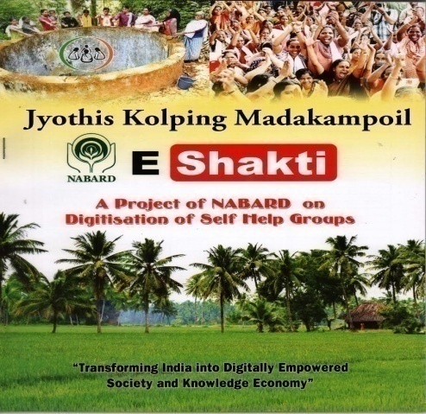
The aims of the project are
- Integrating SHG members with the National financial inclusion agenda
- Improving the quality of interface between SHG members and Banks for efficient and hassle free delivery of banking services by using the available technology
- Facilitate convergence of delivery system with SHGs using Aadhaar linked identity.
There are 200 SHG registered under KAIROS and 6 Animators were selected for the digitization programs. Information of all the SHGs and their members are uploaded into the website. The transactions are updated through 'apps' on android Mobile. All the accounts details of the 200 SHGs are estimated every month and entire details are automatically forwarded to all the SHG members. As a result of this digitization programs, the member wise details of SHGs on saving, lending, attendance and member wise credit history, financial statement of SHGs, Bank linkage details are easily available and accessible to all the members. Micro credit plan of SHG and the accounts are updated on a weekly basis. The SHG accounts are systemized and made transparent through this project.

- 3.KOLPING PROJECT

Kolping India shares the beliefs of Adolf Kolping with the sole aim to enhance the capacities of the poor to enjoy the fullness of life. The process has been initiated through self-help strategy .Strengthening the relationship between the Individual, society and nature had been the focus of intervention of Kolping India to foster human dignity and integrated human development. A special emphasis is also made on self-sufficiency in all aspects of life as the guiding principle of Kolping India .The slogan of Kolping is Good Parent, Good labor, Good citizen and believer. At present, in Kannur Region 94 Kolping groups are functioning with a total number of 1295 members.There are 17 groups for men, 65 groups for women and 12 mixed groups. Total number of male members is 307 and female members are 988. The groups and members were actively involved in all social issues. The members improved their social and spiritual commitment for the family and society. During the reporting period Kolping implemented different type of software and hard ware component for the overall development of the members.
- Capacity Building Programs.

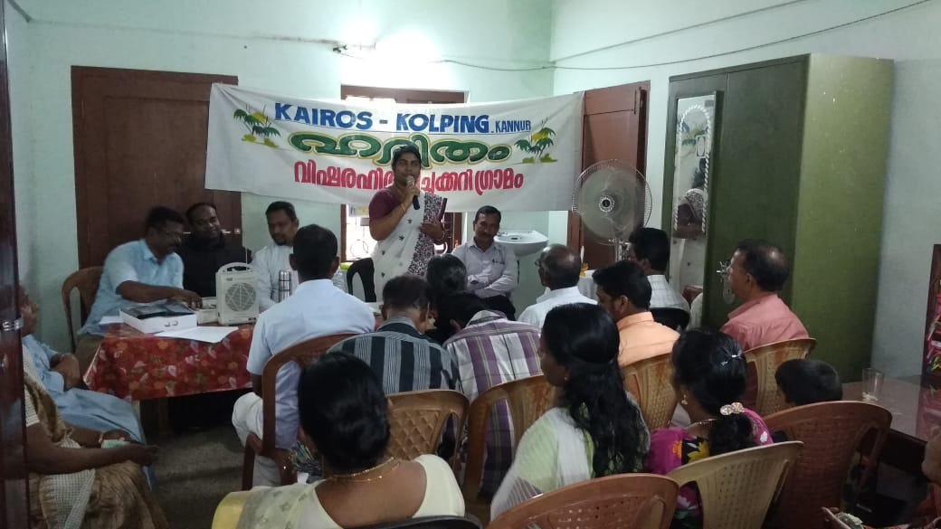
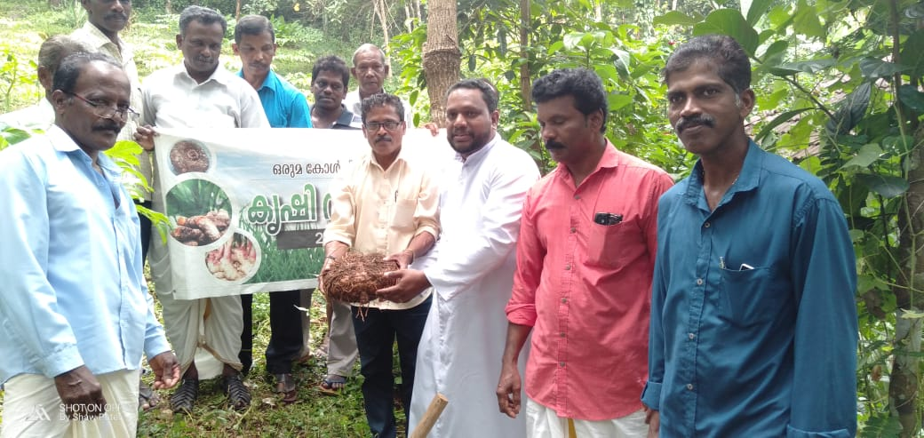
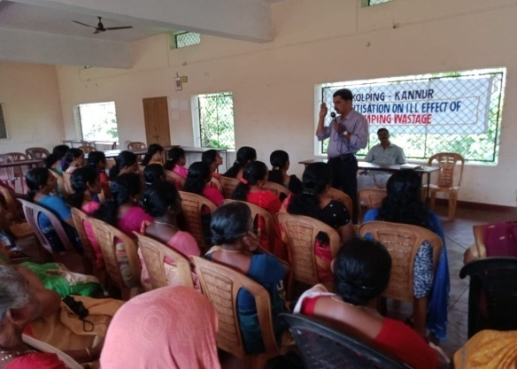
We selected four villages in Thavam, Kayapoil, Keezhpally and Kurumathoor in the reporting period. These villages mostly face several environmental issues like water scarcity, lack of pure water, inadequate sanitation facilities, absence of waste management systems and poor vegetable cultivation systems which affects the community. We have conducted different types of trainings like Awareness class, Rally, Street play, sensitization, interaction with PRI officials based on the environmental issues etc. There are noticeable changes in villages after all these interventions.
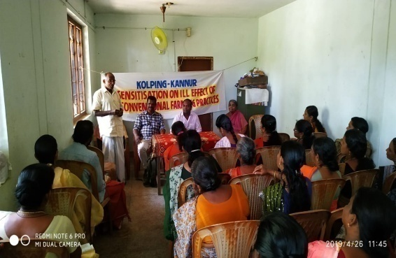
The problem of acute water scarcity was addressed in Thavam village. People adopted the technique of rain water harvesting for this issue. We constructed rain water harvesting tanks and well recharging system with the support of Grama Panchayat and systemized the usage of water especially for summer season. The improper waste management was the major issue in Kurumathoor village. The SHG members started a small waste management system in their homes especially for kitchen waste. The kitchen waste is recycled to fertilizers and used to their kitchen garden. In Kayapoil village, the issue of inadequate sanitation facilities was addressed. People constructed toilets with the support of Kolping India and Grama panchayat. In Keezhpally village, they began vegetable cultivation. All the SHG members in keezhpally started the kitchen garden and some people involved in organic agriculture at a large scale. The village people reduced the use of chemical fertilizers and practiced organic farming. As a result agricultural production and fertility of the soil increased.
Through these continuous interventions, the village people actively involved in all the environmental issues and significant changes evolved in the community. The visibility of Kolping increased and people are more aware of the current environmental issues.
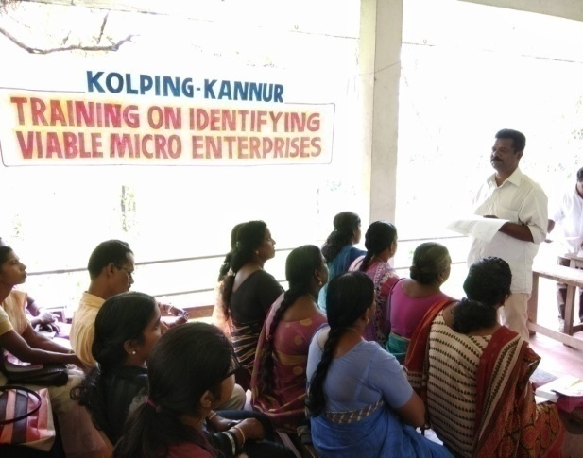
B.Entrepreneurship Development Program (EDP) & Identifying Business Activities
The Kolping members started different type of livelihood programs with the support of local self-government. The percentage of sustainability is very less due to the absence of quality training and close monitoring. The EDP training helped the members to converge their potential and ensure the sustainability of the project. We conducted two EDP training with support of RUDSET institute of Kannur. The training was conducted for selected members of Kolping. The topic was dealt by the expert faculties of RUDSET. The topics dealt were quality of entrepreneur, management systems, accounting procedures and Rules and regulations of the Govt. The second training was meant for identifying business activities. As result of this training participants understood the different methods of identification of Business activities especially for Pair wise matrix ranking. After the ranking the participants identified proper way of selecting suitable Income generation programs. The participants initiated new ventures with the support of Kolping and state Government. They got additional income from their ventures and are looking forward to expand their ventures.
C. Microfinance & Book Keeping:
This is intended to provide an orientation to the leaders of Kolping Group. They were trained in the management procedures of micro financing and keeping of accounts which gave them confidence in finance management and reporting.
D. Training on Leadership:
Leadership is an important function of management which helps an individual to maximize the efficiency and to achieve goals. The Leadership training is an essential element for the group leaders for the effectiveness of group activities. The leadership training was conducted in different areas of selected group of leaders. After the training, leaders effectively managed all the activities of the groups and systemized their duties.
E. Training on preventing domestic violence and awareness to women rights.
Domestic violence is a problem that affects the lives of many women both in the urban and rural areas. Domestic violence has emerged as one of the most serious problem faced by women in our area. The people are not aware about the women’s right and the measures to prevent domestic violence. We conducted training for the selected women leaders. As result of the training the participants became aware about their duties and responsibilities and also about their own rights. The domestic violence cases are reduced and women are more capable of observing their dignity and freedom.
F. Training on effective parenting and strengthening family values
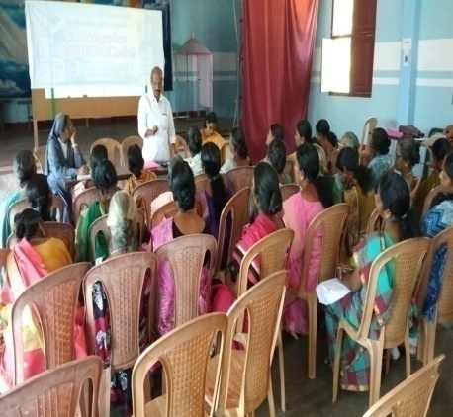
Children need care that promotes positive emotional health and well being for their overall mental health. A positive sense of self as well as the ability to cope with stressful situations is essential. The parents are the resources for children in managing emotional wellbeing, coping with physical and mental changes and managing behavior. The Parents serve to help the children by providing positive thinking, conveying love and respect and to create a sense of security. The parents need to have knowledge about good parenting systems in the present scenario and hence we conducted on training on the issue. The sessions were lead by clinical psychologist Dr. Ummer Farooq. After the training parents could acquire parenting knowledge and a positive attitude and adopt it to their life by practicing them.
G. Conflict, stress management Training
Conflict is inevitable and can be both positive and negative. The stress is normal, excessive stress can interfere with the productivity and can have impact on the physical and emotional health. The training on conflict and stress management is essential for the people to manage these issues. We conducted training for the selected leaders to enable them to manage conflict and stress. The achievement of this training was that the leaders could manage conflict in their group and families and develop some positive strategies in the area of conflict and stress management.
Different Programs
During this reporting year, we have implemented several projects to improve the livelihood, house and sanitation facilities. All beneficiaries who are undergoing this program in a systematic manner could improve their economic, social status and they are brought forth to the main stream of the society
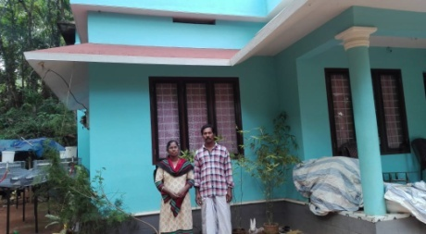
- Housing Support Program
In this year KAIROS selected four poor and marginalized families for the House construction schemes. The beneficiaries completed the construction within the time and could fulfill their cherished dream for a livable House.
- Lively hood support
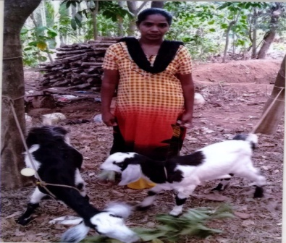
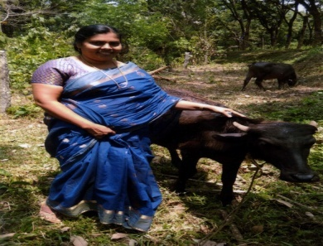
This program aims in empowering the people to develop their self-confidence with the help of the livelihood programs. We have provided the assistance to 22 members to start small self-employment schemes under IIGP and CIGP programs of Kolping India. The members mobilized the rest of the amount from the SHG and other government approved financial institutions in a nominal interest rate .The different type of self-employments started are dairy farm, goat rearing ,fish vending, soap making unit etc. All the self-employment schemes are going well and the beneficiaries are earning additional income. Increased family income has improved the quality of life
- Functional Kolping Groups
KAIROS has promoted around 94 Kolping groups in different villages in which there are a total of 1295members. They have savings and credit programs. Among them there are 17 groups of men 65groups of women 8 mixed groups and 4 groups for children.
- Education Support
Educational support has been extended to 16 professional and vocational students. The students are studying in different areas in the country.
- 4.FAMILY DEVELOMENT PROGRAM (FDP)
The ultimate goal of this project is to establish ways of sustenance to the families of widows, downtrodden, helpless, and economically backward. The program focuses on creating a systematized process of capacity development that will equip the targeted families and the communities to address their relevant and basic needs.
The major activities
With the support of Save A Family Plan India - Family Development Program KAIROS helps 320 families in Kannur and Kasargod districts. An amount of Rs. 900 per month is allocated to each family. It enables the family for the poverty alleviation and to sustain and maintain their livelihood initiates.
In the reporting period we have provided different families in different development initiatives
Category | No of Family | Amount
Small Business Initiative | 100 | 1242000
Infrastructure development | 55 | 643000
Purchase of Goods | 2 | 20000
Agriculture farming | 3 | 34000
Livestock Farming | 56 | 713000
Education | 9 | 127000
Medical Treatment | 11 | 148000
Total | 244 | 3029682

The Other components are EDP training, Timely monitoring meetings with beneficiaries, house visits to monitor the IGPs and regional gatherings and awareness classes in various subjects.199 families have health insurance in government and private sector.
Case study -Development Story of a Wage Earner to a Profit Earner
Before the enrollment in Family Development Program
Sindhu Rajesh is an abandoned woman, living with her only son and aged mother. Before the enrollment in Save A Family Plan Program she was a wage laborer having a meager income. She was under treatment for thyroid diseases and hearing problems. She was struggling to meet the treatment expenses of herself and her aged mother and the educational expenses of her son. The house they lived was in a dangerous situation due to its moldiness. In this right time she got the opportunity to become a partner family of the Save A Family Plan Family Development program.
Starting Development
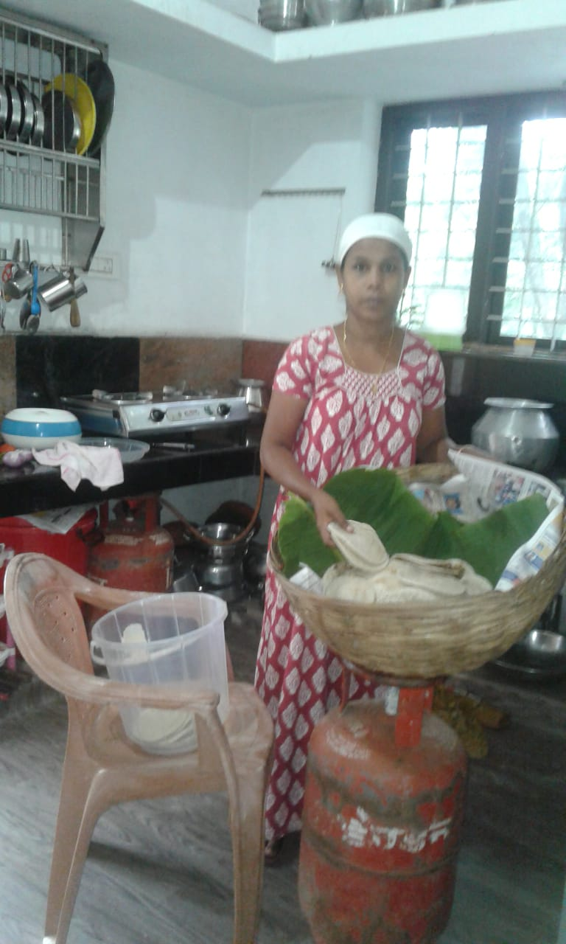
In November 2018 Sindhu withdrew Rs 10000/- from her monthly assistance and started Snacks Making Business at home. Initially she prepared some evening snacks and sold it to the neighboring houses. Gradually she received some orders from the nearby houses and tea shops and accordingly she could earn reasonable income. In November 2019, she again withdrew Rs 10000/- and utilized it for the expansion of her Small Business Initiative. She purchased big utensils and prepared variety of tea snacks and she started to prepare items for breakfast also. She received orders from the nearby households for breakfast items for special occasions like marriage, housewarming and birthday parties and so on. Along with this she started pickle making also. Her earnings also improved with the improvement in her business.
Attaining sustainability
As her income increased she was able to manage her expenses and could save a part of her income. Using her small savings and loan from self-help group she purchased a sewing machine also. Now she is doing tailoring works also at home. For the financial year 2020-21 she planned to use her monthly support for the expansion of tailoring center. Now she has a sustainable income from her ventures.
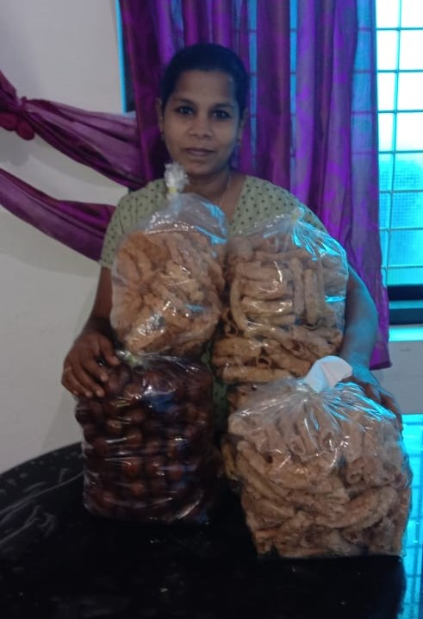
Her old house was destroyed in a heavy rain and now she is living in her brother’s house. She has applied for government’s housing scheme and she is working hard to mobilize money for the house construction.
Now Sindhu is a role model and inspiration for other partner families of ‘Save A Family’ Plan to do Small Business Initiatives. Snacks making is a profitable Small Business Initiative, which can be started with less investment and suitable to rural as well as urban areas.
- 5.STUDENTS PROJECTS-PROMOTION OF SUPPLEMENTARY EDUCATION
KAIROS has submitted a Project Proposal “”Promotion of ‘Supplementary Education’ for ensuring professional Courses and improving the quality and Skills of school going students of Dalits and backward community .The project is to promote the supplementary Education for mainstreaming of the selected students from Dalit communities in Kannur district. It is done by ensuring excellence in education, ensuring upward movement and ushering them to employment oriented education and socioeconomic empowerment. The project implanted in two regions and 22 villages. The major activities are:

A. Formation of supplementary groups at village level and Regional and central level federation
KAIROS organized the village level education training in 20 villages with the support of district level education department. The groups were constituted of parents of the students. The education of the children is the primary responsibility of the parents .The members of the group gather together on a monthly basis and evaluate the educational status of their children. Formed a two federation committee in Payangadi and Taliparamaba and formed the central level Federation also
B. Two days Training for Teachers
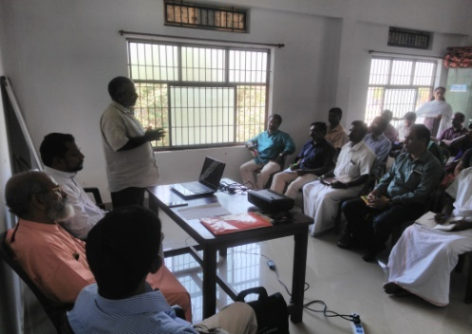
The Government or any other developmental agencies have not implemented so far any such sustainable educational development programs for increasing the quality education for the Dalit and backward students of the community in the project area. Two days training was conducted for volunteers at regional level. 48 Voluntees participated from Payangadi region and 53 volunteers from Taliparamba region. The sessions covered the Roles and responsibility of Volunteers, Child Psychology, management, planning and teaching methods. The volunteers are more confident and could develop their potential from this training and express their opinion and views effectively.
C. Leadership training for students and Parents
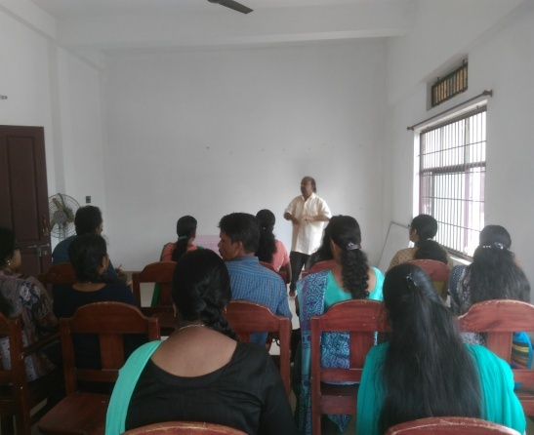
Leadership skills are crucial for both personal and professional development. Leadership training is essential for the students for improving their quality and confidence. The training was conducted in regional level with active participation of students and was group work oriented. The topics covered were Quality of Good leadership, Interpersonal and group communication and basic Managerial skills. The training helped the students to determine their desire, strength and abilities.
D. Personality development Training for students
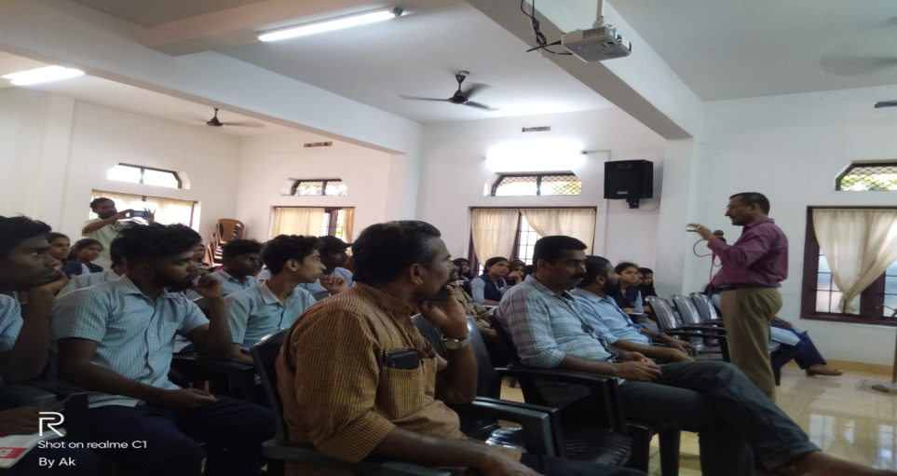
Personality development is not an overnight task. It requires lots of time and efforts to groom and shape personality. The training conducted in central level dealt the topics in Communication, stress management, Behavior modification, conflict management and time management. The sessions were conducted by the experts from the Institutes of Management studies in Kannur. The training improved the will power, confidence, concentration, memory and also focused on the appearance and basic etiquettes on should follow. The class was very beneficial to the students.
E.Children’s day celebration
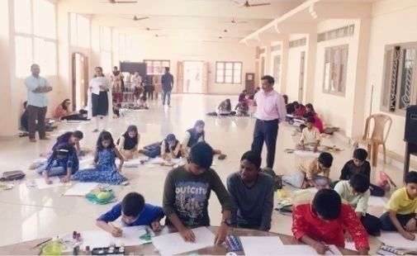
Children’s Day celebrations focused on children and their enjoyment .This year we celebrated the Children’s day on 14 November 2019 at Taliparamaba with different programs such as Children’s rally, Painting competition and cultural programs. More than 200 children participated in the programs. The district level painting competition was conducted in St. Paul’s English Medium School Trichambaram. Forty eight children participated. The program was inaugurated by Mr. Muhammed Allamkulam (Municipal Chairperson, Taliparamba) and Artist Mr. Peter Kolakad lead the programs. The painting competition was to motivate student artists and help them to develop their creative skills by exploring their talents.

F. Career Guidance Training
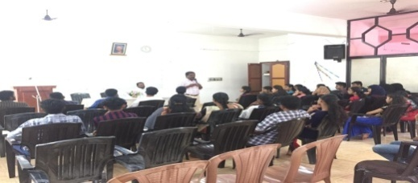
The career guidance is the guidance given to individuals to help them acquire knowledge, information, skills and experience necessary to identify the career options. The people who find it difficult to choose the right career meant for them, career guidance helps them sort this confusion. Through the project, we conducted career guidance class at regional level for the students of classes X, XI, XII. Mr. Jose Thayyil (career guidance trainer in north Kerala) lead the sessions and he briefed the different type of courses in the State, National and International wise and scholarship schemes were also mentioned. The students were made aware of the course and schemes related to their area of interest.
G.Assisting Poultry unit
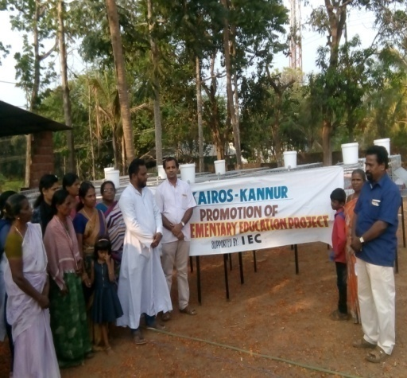
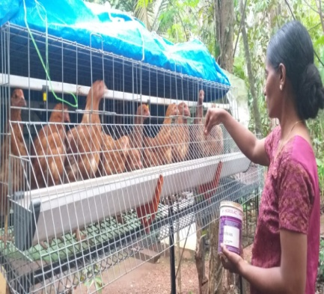
Backyard poultry production is an age old profession of rural families. It is the most potent source for subsidiary income for landless and poor farmers. It is a small enterprise with low initial investment but higher economic returns and can easily be managed by women, children and old aged persons of the households. The supplementary earning through this increases the income of the beneficiaries, thereby enhancing their livelihood. Poultry provide a major income generation activity from the sale of birds and eggs. KAIROS selected beneficiaries mostly of SESG members through the Village Developmental Committees and provided orientation on poultry farming by Veterinary Doctor in Kannur district. We selected total of 100 families in two regions. Each family was provided with 25 chicks, cage, one month feed and medicines. The poultry farm is doing well and is generating income from the venture.

H. Assisting Goat rearing Units
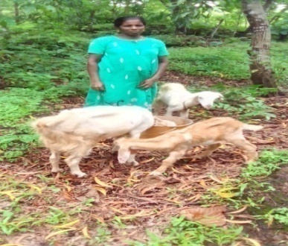
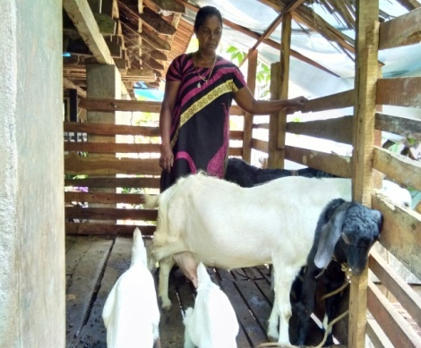
Goat rearing plays a significant role in economic uplifting of the rural poor. Consumption of goat meat is increasing rapidly due to its nutritional value social acceptability. Goat is a multi-functional animal. For the goat farm unit, the initial expense is very low. KAIROS selected beneficiaries, mostly its members through the Village Developmental Committees and provided orientation on Goat farming with support of Veterinary department. The families have started the goat rearing project. The project is going well and has increased income of the family. The additional income from the goat rearing project is used only for the educational purpose of their children. It will change their economic and social status.
I. Training on Income Generation Program
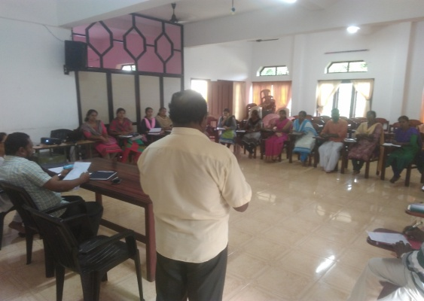
We have conducted the Training on Income Generation programs for selected people from the poultry and goat rearing project beneficiaries. The objective of the training is to develop entrepreneurial and managerial skills among the entrepreneur. The training covered the topic of enhancing abilities and potential among entrepreneurs and to increase the ability to manage the unit. The training was lead by the faculty of RUDSET institute Kannur. The training enhanced more knowledge on making the Income Generation programs, strengthening their entrepreneurial capabilities and motivates and promotes potential entrepreneurs. The confidence level of the participants improved and they began to undertake the income generation activities such as poultry and goat rearing.

6.KERALA LABOUR MOVEMENT
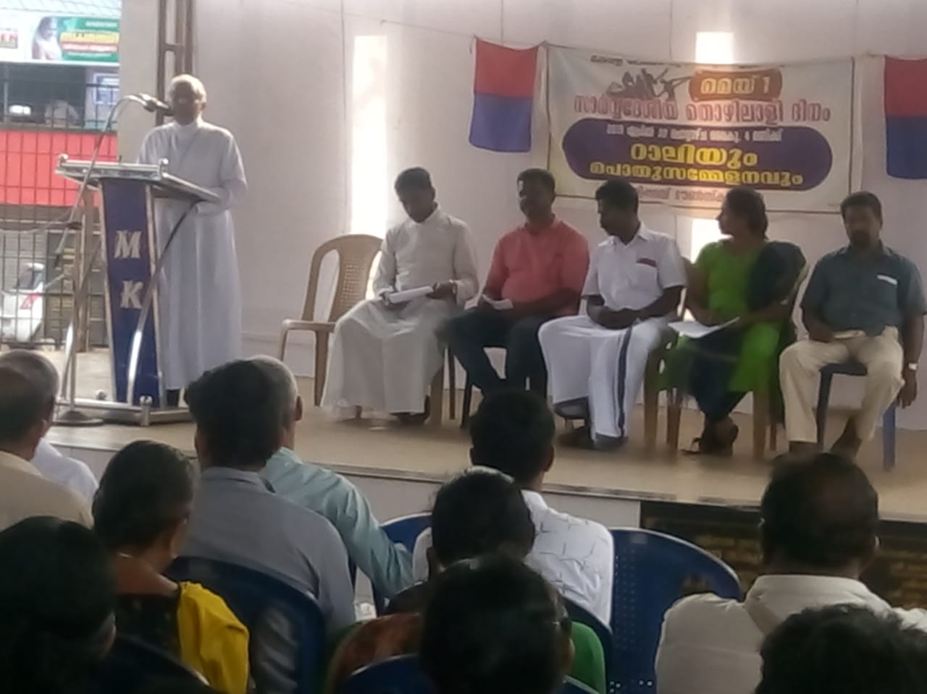
Kerala Labour movement works in under the supervision of KAIROS Kannur, having an elected regional committee and having committees in different areas. At present Tailoring, shop and other establishment, Domestic workers are very active in the forums. Women leadership is also active in our region. In the reporting period we have conducted meetings of fishermen in Burnassery and celebrated May day at Taliparamba and construction workers meeting held at Thavam. CBCI labour commission Chairman, Rt.Rev.Dr.Alex Vadakumthala, KLM state director Rev.Fr. George Narupukalayil was present in the program. In Tailoring Kshemanidhi, 180 active workers are enrolled in Kerala workers forum and eighty members are renewing yearly. Seven hundred odd members enrolled in domestic workers forum. Nine hundred and twenty three members are registered in KLM suraksha.KLM intending to activate different forums and to register more workers in these forums and to work as a trade union in our area.

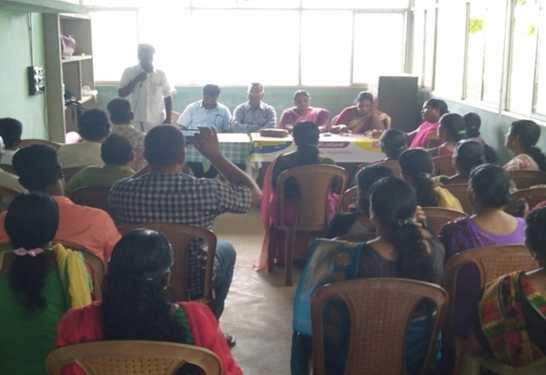
6.NAVAJEEVAN
Navajeevan is a disaster mitigation project led by CARITAS INDIA and KAIROS KANNUR. We have had great tragedies for the last two years. The plan is to increase the capacity of people to cope with disasters in the coming year. It is being held in 10 wards of 6 panchayats in Kannur district. As part of this, PDRA was conducted in all the wards to study the number of people affected by the disasters and to prepare reports to the panchayat.
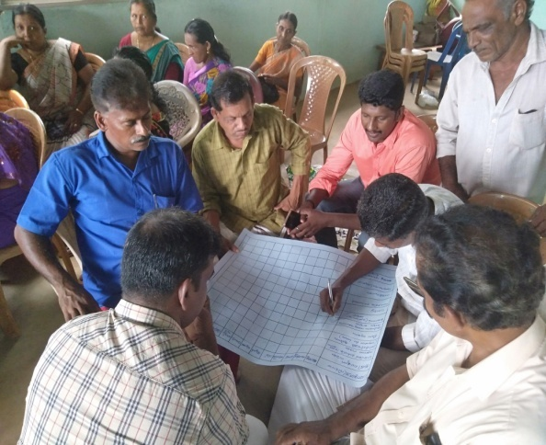
PDRA, it is a data collection method. There are six methods in use during the time of PDRA. The participatory disaster risk assessment is a tool to assess of disaster risk, hazards, vulnerabilities and capacities in the communities by themselves and to cope with the actions to prepare, mitigate and manage the disasters in the communities. In addition, a 10-member Village Development Committee was formed to deal with disasters next year. This committee has been instrumental in carrying out a number of disaster mitigation projects and raising awareness among the people, and continues to do so.
7.NATURAL RESOURCE MANAGEMENT
A.Environmental protection & Conservation
Natural Resource Management (NRM) is one of the major and important areas of intervention of KAIROS and has a very good track record in the implementation. The aim of the project is the preservation and conservation of Soil, Water and bio mass. All the activities of implementation based on the three heads such as, Soil and water conservation, livelihood support and Capacity building of the watershed community. During the reporting period, KAIROS was implementing the four watersheds project under Western ghat development cell. Alakkode GP,Cherupuzha GP,Naduvil GP and East eleri GP.As a result of the project implementation, people understood the need of conservation of Natural recourses. The watershed committee ensures the sustainability of the activities and maintains the structures of stone bund, Check dam, Retaining wall, loose board check dam etc. It provides livelihood support too. The Watershed committee conducted the Neerthada gramasabha and presented the status of the programs and divided the roles and responsibility to the people. The people are more aware and take up the roles and ensure the sustainability of the program.
B.Environment day
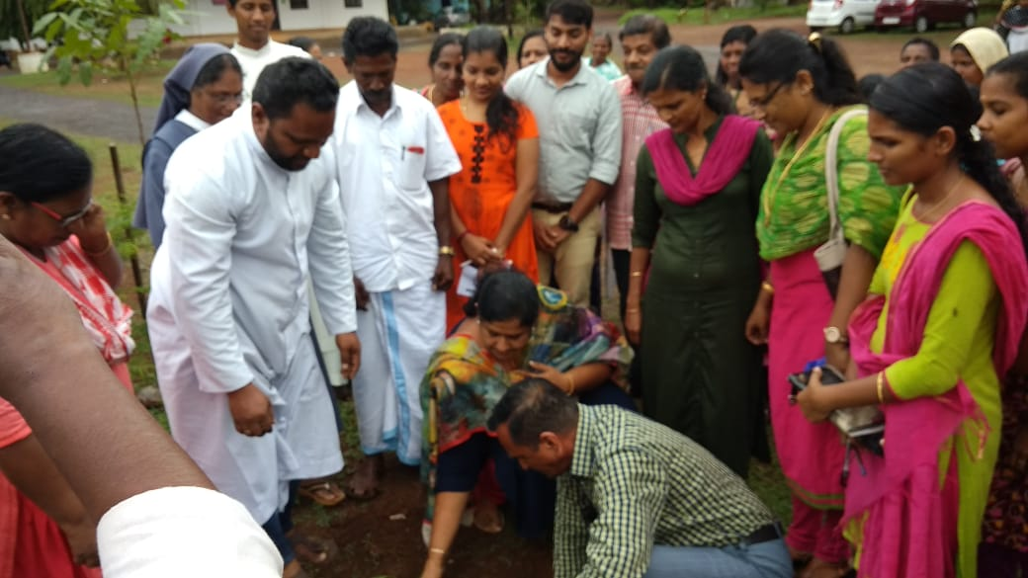
Every year KAIROS celebrated the Environment day with different programs to spread awareness among the common people about the issues of the environment. The environmental issues nowadays are threatening to the planet and everyone must be aware to give their positive efforts to solve the crisis. Environment day was celebrated on June 5th at Kottukapara. Awareness classes, tree plantation, Natural food preparation and Health camp was conducted as a part of the program. Health department and Laboratory team associated with the program. The Ayyankunnu Panchayat ward member inaugurated the public function. Members prepared homemade organic food and served in biodegradable products as an initiative to conserve the environment. A health checkup to check Diabetic, Pressure and Cholesterol was conducted. The day celebration promotes the people to change their attitude towards the environment to build a safe future.

8.INCOME GENERATION PROGRAM–KSBCDC
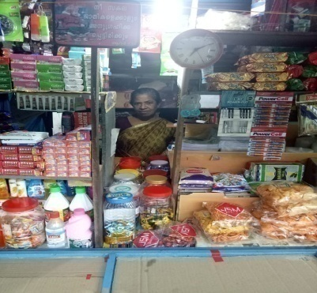
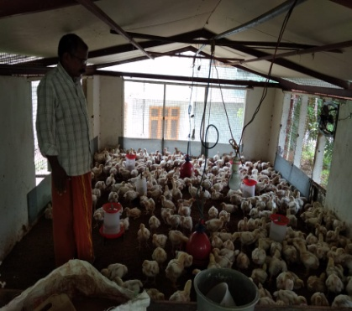
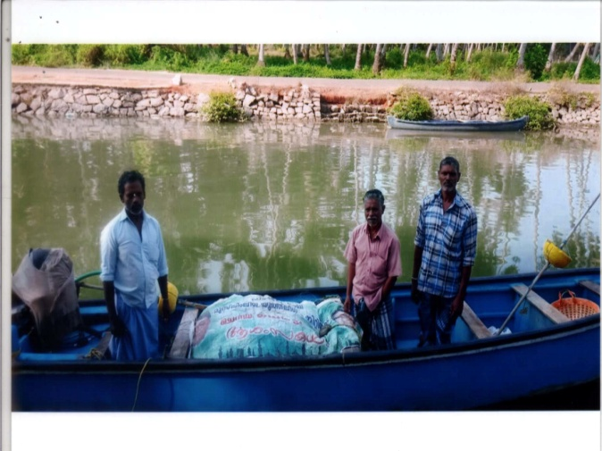
KAIROS has carried out several projects to strengthen the poor communities and to uplift the living standard of the most vulnerable people. The promotion of Income Generation project is successful an increased the income of the people. Most of the people in our target areas are coolie workers and they get less income from their work .They are in need of extra income from any other source. The people are ready to work in the field of Income generation programs. KAIROS arranged the financial support from the financial Institutions especially through KSBCDC in nominal interest rate. In the reporting year, around 504 individual prospective entrepreneurs selected from 39 groups started and were helped to be sustained. Some of the ventures started are Rice mill, Poultry farm, Ice cream shop, stationary shop, garments unit etc An amount of Rs. 85,45,000/- was channelized from KSBCDC which was used to support the deserving candidates/families to start IGPs. The launching of the program was inaugurated by Mrs.P.K.Sreemathi teacher the Member of Parliament in a function presided over by Vicar General Msgr. Devasi Erathara. KSBCDC Kannur district. Manager, Mr. Sudhakaran led the sessions. The Income increased from the ventures and changes the life style of the people
9.EARTH DAY CELEBRATION
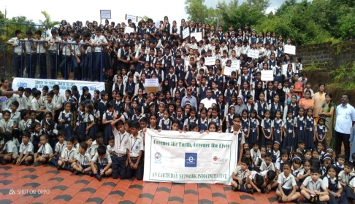
The earth day celebration which was jointly organized by KAIROS Kannur and Caritas India was conducted in Parassinikadavu Kuzhichal St Mary’s English Medium High School, Taliparamba. The program commenced with a prayer by the students of the school. The Principal Rev. Sr. Kavitha welcomed the gathering and conveyed the importance of Earth day and the need of celebrating it. Director Rev. Fr Shaiju Peter inaugurated the program. Medical officer of Mother and Child care centre Dr. Vinod gave a class on Hansen’s disease and Vice Principal Rev. Sr. Lissy expressed vote of thanks.
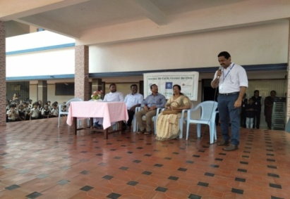
The inaugural session was concluded and the activities began by stamping hand impressions in mud on a white canvas which depicted the relationship between man and earth. Rev. Fr.Shaiju Peter inaugurated the ceremony and then all the teachers, students and staff members of KAIROS imprinted their palms expressing solidarity. After that, a painting competition and elocution completion was also held for the students. Prizes and mementos were distributed to the winners by our Director.
10.ATHIJEEVANAM.
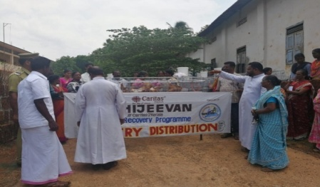
The unexpected flash flood resulted in loss of life, land sliding, soil erosion, and house collapsing etc in the villages of Anayandagiri, Malayampaadi, Keezhpally, Kottukappara and Parakkappara. The effected people were in the operational areas and beneficiaries of KAIROS. Caritas India supported to the beneficiaries through the Athijeevanam project. The project aims to rebuild the society and develop their confidence through the interventions and providing assistance for the victims. We have provided resources for poultry farming for 100 families, which was consisting of 25 chicks and modern iron chicken cage and assistance for 16 house repair , 8 toilet constructions, 7cow rearing and 7 goat rearing

A. House repairing and Sanitation
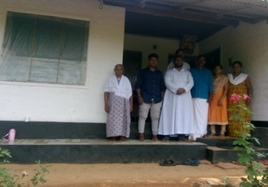
KAIROS provided assistance to repair 15 houses, which were partially damaged in the natural calamity. The beneficiaries completed the house repair in the stipulated time with financial and physical support from Self-help group and Vikasana samithi. The unit cost is Rs.50000. Their houses got repaired and they were now able to live safely in their house. They were relieved from their shock and very happy and are leading a normal life .We provided better sanitation facilities for 10 families .The unit cost of the activities was Rs.15000.The ten families accessed to safe sanitation. These two activities are designed to provide social security, health and hygiene.
B. Livelihood Program
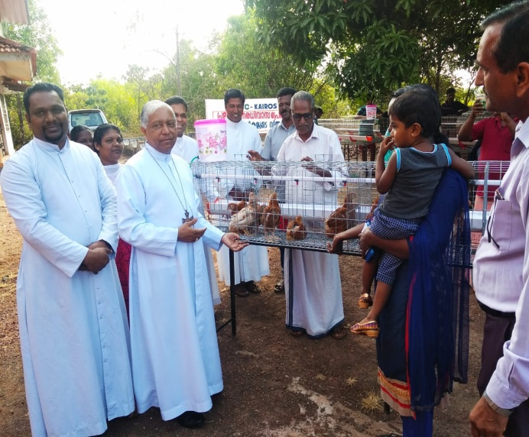
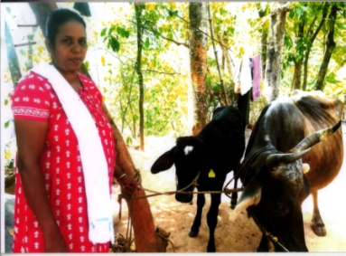
The activities are designed to generate additional income to the family, as the benefiaciaries were not permanently employed (daily wage earners). To address their unemployment, through this activity we supplied two goats to ten families and one cow to seven families .We have provided resources for poultry farming for 100 families , which consisting of 25 chicks and an Iron modern chicken and cage. We provided feed for one month to each beneficiary. The BV 380 chicks and cages were arranged from the Govt approved farms. The livelihood training was organized with the help of Animal Husbandry Department and the additional fund required for this program was mobilized through the existing structures of KAIROS .As a result of these activities, they got additional income from their venture .As a result of this project the targeted families retained their strength and courage and moved to normal life.

11. Social Impact Study
KAIROS was selected as an authorized agency for conducting social impact assessment study in connection with the land acquisition for different developmental project of the Govt of kerala, in Kannur and Kozhikode Dt.
During the reporting year seven projects, as shown below, had been completed in all respects.
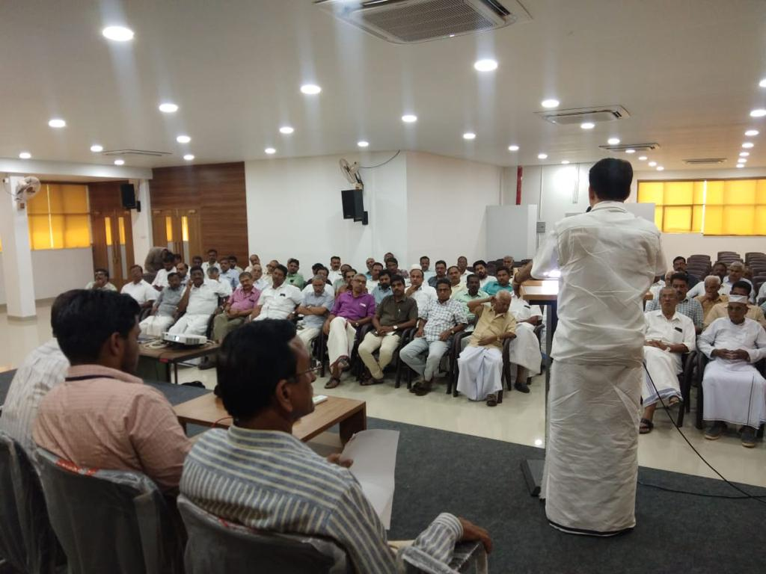
- LA for Koodali benganaparama Industrial Estate for Koodali GP.
- LA for New Track for Kunhimanagalam Changurichal Railway bridge for Southern Railway,
- Drinking Water Project for Water Authority,Pannoor Community Health Centre for Health Deparment ,
- Peralassery AKG Smruthi museum for Musuem Depatment
- LA for approach roads for Erangholi Bridge in connection with development Thalassery Valavupara Road for KSTP
- LA for the construction of waste management plant for Chirakkal GP
Kozhikode Dt.
- LA for the approach road for Thondilsa kadavu bridge
- LA for the contruction of Syrag fly over in Koduvally
- LA for the approach road for chediyala kadavu bridge
- LA for the approach road for Naddammal kadavu bridge
- LA for the approach road for Padannillam bridge
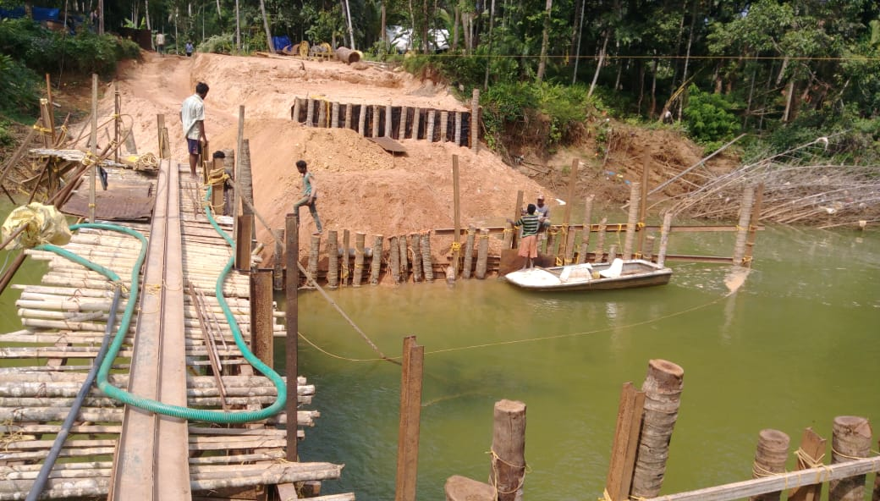
- LA for Kozhikode cyber park
- LA for the approach road for Farooq,Kadalundy ROB
Besides this we have already prepared and submitted projects for KIAL drainage 2 and 3, Muzhappilanagad KTDC beach resort, Textile Corporation,Thallasery Valavupara at Pazhazzhi,Pinarayi Convention centre and Ullur Kadavu Bridge of Kozhikode but we haven’t received these projects due to stiff competition. .The total projects amount comes to Rs.6,14.469.Besides the monitoring benefit ,the timely submission of reports , the good will and image of KAIROS increased to deferent departments of Kannur and Kozhikode district and southern Railway
12.Flood Relief Program
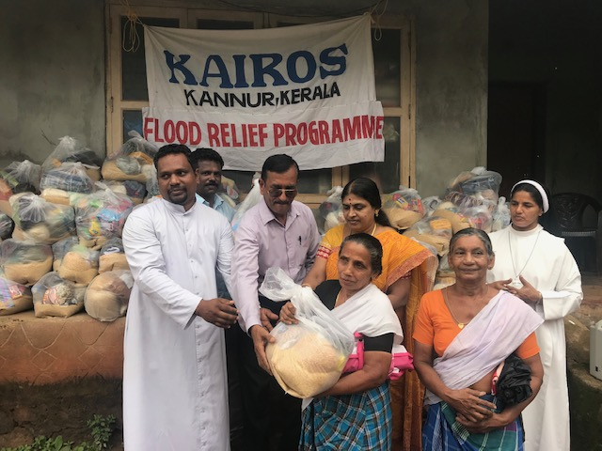
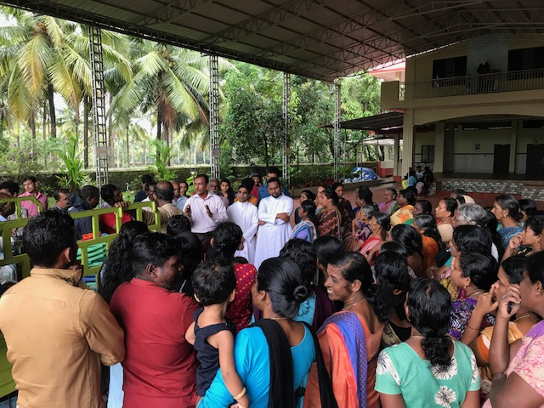
During august 2019 the low line areas of Cherukunnu Grama Panchauyat especially Kattakulam, Pallikkara, Thavam, Dhalil etc. witnessed heavy flood due to heavy rain around four hundred families were evacuated from their house and they were taken to the nearby relief camps .Majority of the families were our beneficiaries. KAIROS director and staff members paid immediate visit to this centers and emergency assistance such as mat, Bed sheet, Medicine, drinking water, food materials etc. were arranged to their centers. After they returned to their homes we supplied special kits including utensils. Several villages of high range of Iritty were also badly affected by the overflow Irritty river and Cheenkanni river. In total three thousand kits were distributed to the affected families of Payam, Kelakam, Cherukunnu,Kannapuram,Pattuvam ,Narath and Pappinissery Grama panchayat. To affected areas of Narath GP was also attended by KAIROS .It may be noted that we have no connection to these areas as it is fully inhabited by poor and backward community.

13.Flood Housing Scheme
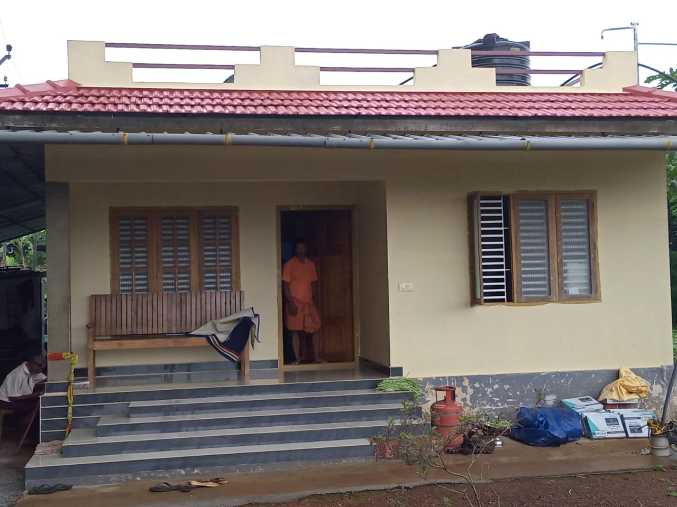
KAIROS provided the support of house construction with the help of Souhredaya social service society and Kerala Catholic Bishps council. We have constructed 20 houses in most flood affecetd areas of Kattakulam,Thavam and Cherukunnu.The total cost of one house was 3 lakh rupees. We have provided Rs.75000 and rest of the amount mobilised by bank and other finacial institutions.The construction works completed in time with fiscal and financial support of local stuctures of KAIROS such as Self help group and Vikasanasamithi’s.The twenty families are living in safe house and have regained their confidence.
14. JEEVAN MADHUR
The scheme is introduced by KAIROS in the year 2007. The purpose of this scheme is to support the people who are having meager income. The beneficiaries deposit an amount of Rs.100 minimum that can be monthly, quarterly and yearly. In the reporting period more than 325 policies are matured and 423 policy holders paid their amount regularly.
15. Micro finance
Micro finance services are meant to low-income individuals, because most of those trapped in poverty, or who have limited financial resources, do not have enough income to do the income generation activities and other social needs. The people who have less involved in their family budget systems and saving procedures .The KAIROS formed the self-help groups (SHG) and SHG federations for the purpose of strengthening the people and promoting the savings .The KAIROS has formed more than thousand SHGs in Kannur and Kasaragod districts in the last twenty years .The 432 SHGs and 6 federation groups were actively involved in all the social activities of the society. They began to save their little earnings and achieved several targets of financial promotional activities. The money they saved and redistributed among the members helped them to overcome their difficult situations. More than 1.5 crore rupees was collected from the people per year and redistributed to their needs. Some SHG groups started the livelihood programs with the support of Govt financial Institutions and Government schemes. The Micro finance system changed their family life and improved the financial status.
16.Women’s Day Programme
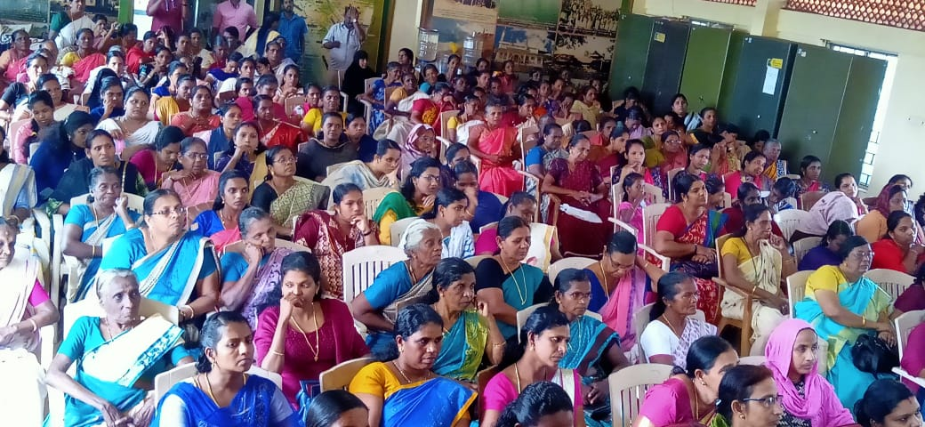
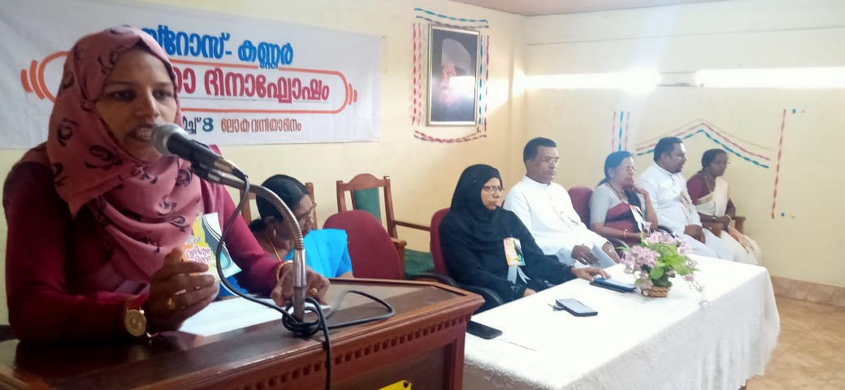
Inter national Womens day was celebrated on March 9 at Madai Grama Panchayat Auditorium in Payangadi.The theme of the year 2020 was “Iam Generation Equality .Realizing Women’s Right” The programs were public gathering, Awareness class and cultural programes. Selected women leaders participated in the program.The awareness class was lead by Dr.Raja Lakshmi and covered the topics of Roles and resposibility of women in the society and womens right.The women became more aware about the roles and rights .The public function inaguarated by Smt.Suharabi Panchayat president of Madai GP in the presence Smt.M.Mymunatha Panchayat president of Chapparapaduvu GP. The dignitaries honoured the selected women in social work of the last twenty years and young women who performed well in the educational field. Cultural programs were also conducted. All the programs were managed by the women leaders in the field and staff. The programs highly motivated and improved the level confidence in the women leaders in our areas.

17.KAIROS Day celebration
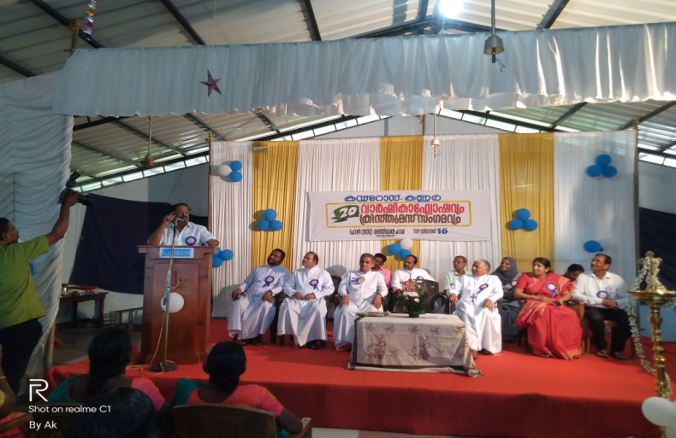
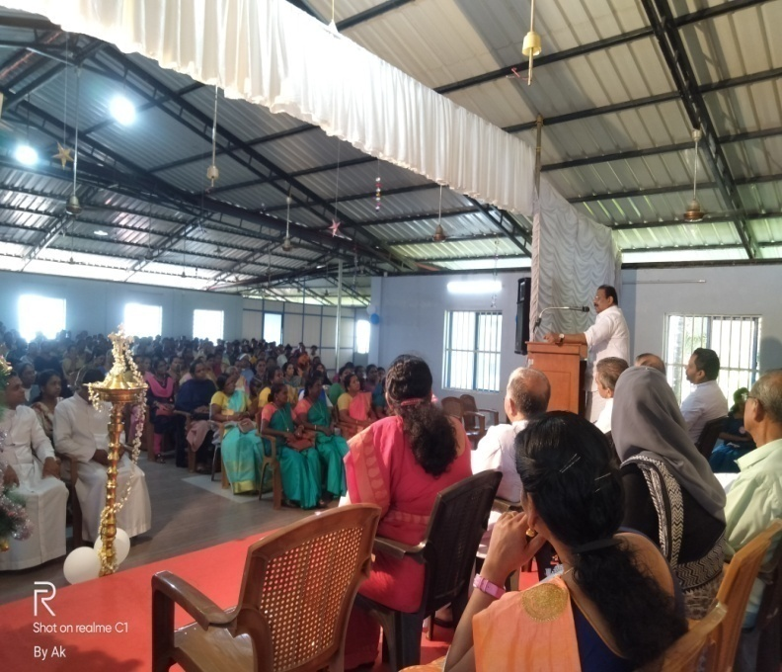
KAIROS celebrated its 20th Aniversary at Cathedral Hall Kannur.A colourful function was arranged .The main events were public gathering, Leaders meet,Fund distribution and cultural event.The public function was inagurated by Mr.K.Sudakaran MP with the presence of KAIROS president Bishop Rt.Rev.Dr.Alex Vadakumthala. The former directors Msgr.Rev.Fr.Clarance Paliath,Rev.Fr.Benny Manapat,Rev.Fr.Benny Putharayil were also present in this program. Kannur ADM, Mrs.Mercy Kutty honoured the staff members of KAIROS Mr.Dennis, Mr.M.V.Chandran who has served the organisation for the last two decades. Bishop honoured the former directors their growth for meritorious service which enabled the smooth development of the organisation.The structural level performance award winners were, the best SHG Fr.Teferel SHG malayampadi, The best Vikasana samithi Pattuvam VS,The best KAIROS oriented scheme Kurumathoor scheme and Best Regions are Taliparamba and Iritty regions.The awards were given by first director Msgr Fr.Clarance Paliath.Income Generation project fund was distributed by Fr.Benny Manapat. Before the inagural function Mr.E.D Joseph Director of KRIPA counseling college gave a motivational session. Director Fr. Shyju Peter welcomed the participants and Mr. KV.Chandran delivered the vote of thanks. More than 400 leaders and beneficiaries from our different units attented the program.
18. WIDOWS PROGRAMES
A. Widows convention
KAIROS formed special groups of widows’ groups; they were left behind from the main stream. Widows SHG formed in the nine units of Taliparamba and Pilathara Region. In the reporting period we organized the widows’ convention in Taliparama. A public function and awareness class were conducted .The class was lead by Widows Charitable trust Trichur. The topics were dealt with Government schemes of widows, and widows’ rights in the society and confidence building. The public Function was inaugurated by Taliparamba Municipal counselor, Smt. Rejani Remand. She also explained the different schemes in Municipalities. The district level widow committee formed and planned Livelihood trainings .The confidence level improved and we formed a strong widows group in new units.
B. Livelihood training
Widows are involved in two kinds of struggles in addition to overcoming grief, their social and economic background is not sound. The families are depending on their limited income and they need an additional income or additional income generation program. KAIROS conducted the livelihood training for selected widows with the support of Kerala Social service Forum .The training was conducted at Taliparamba. Mr. Varghese Paul lead the session included theory and practical sessions for soap making, Detergent making, Surf etc. The most of the participants started soap and surf making in their home and marketing to the neighbourhood. They get an additional income from their venture and change their life and improve the self-confidence .The widows group were active with small scale IGPs and develop the team spirit.
The widows group separately celebrated the women’s day in Poovam and Embate with the public function and class. Embate public function was inaugurated by Fr. Antony Francis and class lead by Mrs. Mary. Ward member of Madayi Panchayat. Poovam Program was inaugurated by Mrs. Latha Ward member Pariyaram Panchayat. The programs motivated their life and helped to keep their group effectively. The group activities are going on well and has enhanced their efficiency

Conclusion
The adverse climatic condition very badly affected the families residing by the banks of rivers. KAIROS took it as a challenge and tried its maximum to extent the helping hands to the needy in the community. The projects are undertaken by KAIROS during the reported year. Significant changes are noticed by giving financial assistance through KSBCDC. Many of them started income Generation program and their social and economic status changed remarkably. Our timely intervention in the flood affected areas was now visible. The journey of KAIROS in serving the needful is continuing and the reported year was filled with a wide variety of projects and interventions. Despite the withering resources, KAIROS is keen in being committed to its duties and is looking forward to extend its helping hands to its community in the upcoming future

