KAIROS

Annual Report
2016 -2017

Introduction:
Kannur Association for Integrated Rural Organization and Support (KAIROS) was formed and registered under Charitable Societies Registration Act in 1999. This is the official organization of the Mission Diocese of Kannur for the Socio-Economic Development of the poor and the marginalized. KAIROS is a non-profit non-government organization functioning for the development of rural women in 65 villages of the northern districts of Kerala i.e., Kannur and Kasargode.
KAIROS is equipped with skillful staff members who are committed to the cause of the poor and marginalized, especially the women. Our staff includes the Executive Director, the Associate Director, the General Coordinator, the Project Officer, the Health Coordinator, the Gender Coordinator, three Regional Coordinators and 65 Village Coordinators. Besides this, there is a squad of administrative staff to carry out the daily business of the office.
KAIROS had been entrusted with the already existing People’s Organizations – the Women’s Organizations and Credit Unions – formed and facilitated by the undivided Diocese of Calicut. Later KAIROS transformed these People’s Organizations into SHGs, and, clustering the SHGs, Village Development Councils (VDCs) were formed. The women SHGs were supplemented with the available resources with KAIROS. Now the Organization is running short of financial resources to continue its mission and its supporting role. It is difficult to continue supporting the ever increasing needs of its target community and hence decided to shift its approach to the grass-roots level groups in making them self sufficient. In order to effectively involve in the development sector, KAIROS decided to bridge the resource gap for its various development interventions. KAIROS has several consultations and has conducted participatory process before formulating this proposal. As per the present situation, the operational area of KAIROS has divided into six regions in which there are 539 SHGs (Both men and women) 82 Kolping Units and 62 children’s groups (Balavedis). All these CBOs cover a total 28536 beneficiary families.
- FAMILY DEVELOPMENT PROGRAM
KAIROS gives special support and care for vulnerable families in its area of operation. Around 320 families had been specifically selected for providing support for their overall development. Material as well as moral support had been extended to these families. For example, support is being given for starting self employment schemes as their income generating programs. We also give support for the marriage of the girl children, education, (especially for girl children) housing and sanitation. Many families have been involved in self employment schemes with the financial support of the Banks as they are linked with such institutions. These families are leading a joyful life and their children are enjoying the facilities of the main stream of social life. The Family Support Programs created such a situation that these families are counted and considered and merged to the main stream. Given below are some of the examples of the progress/success of the supported families.
CASE STUDY
EMPOWERMENT OF AN EMPLOYEE AS AN EMPLOYER
Stage of under development
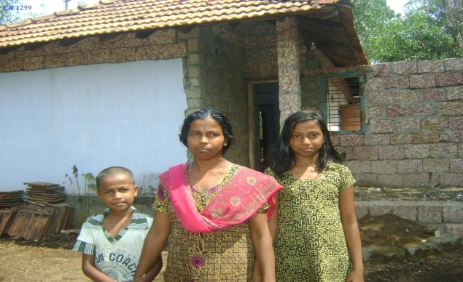
Berthalomiya Rosa and family are living in Mudikkanam unit under Pilathara region. Her family consists of two children. She lost her husband after the birth of the second child. After the death of her husband, she started to work in a tailoring shop on daily wage. She was getting meager wage and struggled to meet daily expenses. She lived in an old, single room house given by Fr. L M Zucol, a legendary missionary in the diocese.

Changes begin
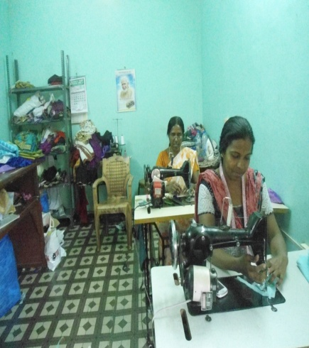
She was selected as a Family Development Program beneficiary in the year of 2012. After the selection she participated in orientation classes conducted as part of the program. She became more and more confident and enthusiastic to life. She joined a Self Help Group and started the habit of saving small portion of her income. By using the first monetary help from Save A Family Plan she started tailoring work at home. She purchases cloth materials from wholesale shop, stitches and sell it as per the order received from neighbors.
Taping government resources
With the guidelines from our FDP animator she received Rs. 50,000 from Saranya Project. She could also avail a loan of Rs 1, 00,000/- from Kerala Gramin Bank to start small business venture. She receives widow pension regularly. She joined in the Suraksha Scheme (Kerala Labour Movement) and deposits the premium regularly.
Expansion
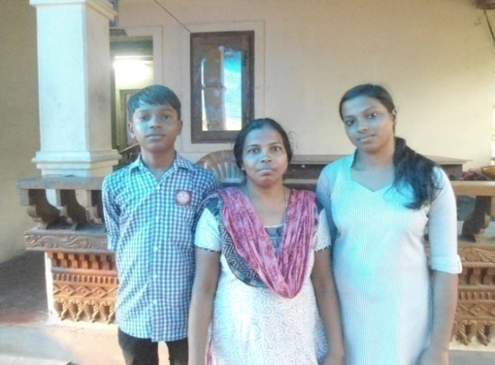
Using SAFP fund along with the government resources and bank loan she shifted her tailoring work from home to a nearby town. In the beginning stage, she was alone. In the next year, she expanded the tailoring unit with the financial support of Save A Family Plan program. At present she is able to provide employment to one more woman from neighborhood. Her income increased to Rs 500-800 per day. Now she is able to meet her expenses and she has a good saving in Self Help Groups.
Improved standard of living
At the time of selection her living condition was very poor. She depended on a public well for drinking water. She could dream about constructing a livable house with basic facilities. As her income increased, she saved a share of her income to fulfill her dream. Using her savings, along with the loan taken from Self Help Group, she could construct a new lovely house. She used some amount from SAFP fund for the construction of a latrine. She could dig a bore-well as well.
2. KOLPING PROGRAME
Kolping envisages that a member becomes a Good Christian, a Good family member, a Good worker and a Good Citizen. At present, there are 82 Kolping Groups and the total number of members comes to 1087. Out of these, 12 groups are exclusively men groups, and 5 mixed groups. The total male members are 207. Presently, other religious believers are also selected as members. The program provides different types of trainings in skill and personality development and, thereby, increases their socio-economic status.
Different Programs
A. Livelihood program
During this reporting year, we have already given financial assistance to 39 members to start self employment programs under IGP and CIGP. Consequently, their economic condition has remarkably changed and as such their social status developed and they feel more confident to face their life struggles.

B. Housing Support Program
Kolping Society takes special interest in supporting the poor and the marginalized families to fulfill their dream of constructing a house. The current year five families were helped under the housing program.
C. Capacity Building Program
Capacity building program is organized to convert the people from the grass root level as leaders and service providers. After such trainings they undertake activities which lead their groups into achieving a knowledge base and formulating an action plan based on various topics. Below given are some training programs conducted by us, the duration of which differ from one day to three days. The trainings were on:
a. Microfinance & Book Keeping:
This is intended to provide an orientation to the leaders of Kolping Group. They were trained in the management procedures of micro financing and keeping of accounts which gave them confidence in finance management and reporting. Given below is the statistics showing the details of participation in the different trainings.
SL. No. | Place | No. of Trainees
1 | Malayampadi | 12
2 | Aripambra | 17
3 | Kurumathoor | 21
4 | Kayapoil | 12
5 | Korankode | 13
6 | Korankode | 14
7 | Thavam | 20
8 | cherukunnu | 17
9 | Bakkalam | 16
10 | Thavam | 18
11 | Cherukunnu | 15
b. Training on Leadership:
There is reluctance among the people from the grass root level in taking up leadership of groups at lower and higher level. To encourage them, especially the women, KAIROS organized and conducted leadership development trainings as per details given below.
SL. No. | Place | No. of Trainees
1 | Kannur | 32
2 | Kanhangad | 22
3 | Kavunchal | 33
4 | Punchakad | 20

c. Entrepreneurship Development Program (EDP) & Identifying Business Activities
Employment and Self employment Schemes, in which rural people are involved, build an economic base to these families. However, the rural communities are ignorant of such schemes and financial supports. To overcome this, EDPs are conducted at rural areas. In this trainings encouragement, motivation, leadership, and taking initiatives are the main topics dealt with. At the end of the training the participants are given chance to identify their business activities on the basis of their talent and aptitude. This year we could conduct only one training program at Thaliparmaba in which 31 Kolping members participated.

d. Women & Child Protection
KAIROS conducted five awareness seminars on laws concerning women and children protection for a group of women selected from among the Kolping Leaders. Given below is the statistics of the training program:

SL. No. | Place | No. of Trainees
1 | Chalil | 32
2 | Kanhangad | 23
3 | Bakkalam | 40
4 | Thavam | 35
5 | Kannur | 65
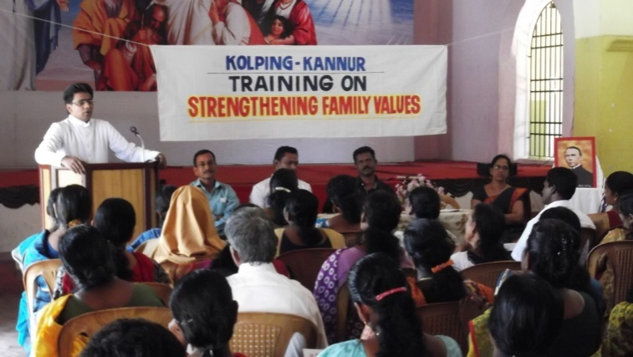

e. HIV Prevention and Care
Awareness on the care and protection of HIV/AIDS infected and affected is the need of the hour. The general tendency of isolating the infected and the affected has not yet changed. Our effort has inspired the people not to isolate the patients but to take care of them and rehabilitate them in the community itself. Eventually, the infected and affected families now receive better support from the community. The program participants are mainly from Self Help Groups and Kolping Groups. Details are given below:
SL. No. | Place | No. of Trainees
1 | Kannur | 182
2 | Kannur | 112

f. RTI & Fundamental Rights
It has been observed that many people are unaware of the RTI Act and their Fundamental rights; as many has complained about the type and quality of services they receives from the government service providers. As a response, we organized two seminars on the topic. The outcome of the program is yet to be measured. Program details are given below:
SL. No. | Place | No. of Trainees
1 | Bakkalam | 50
2 | Kannur | 41

g. Orientation on family values
We felt the need to impart awareness on family values on the increasing number of divorce and suicide cases. Being a Church based organization; KAIROS gives top priority to address the issue. Responding to the need, we conducted three classes the reporting year:
SL. No. | Place | No. of Trainees
1 | Iritty | 25
2 | Anayandagiri | 49
3 | Pilicode | 28

h. Networking & Linkages
Networking is for obtaining collective strength to be exercised by the groups to achieve higher targets and objectives. The methods and procedures of networking among different people’s groups are imparted to the participants. They were also oriented on establishing linkages with financial institutions and organizations of similar nature.
SL. No. | Place | No. of Trainees
1 | Kannur | 23

i. Organic Agriculture Practises
Agriculture should support men as well as the Mother Nature. The present agriculture practice is killing the soil making it futile. It is generally believed that organic agriculture will make a difference. But knowledge should be imparted in this line. KAIROS is pledged to make the people aware of the organic cultivation practices and methods. In this line, we organized awareness programs selected members from different groups:
SL. No. | Place | No. of Trainees
1 | Neruvambram | 28
2 | Kunhimangalam | 55
3 | Cherukunnu | 30
4 | Mariapuram | 42
5 | Cherukunnu | 38

j. Fabric Painting and Fashion Designing

The Training was for 15 days for selected women who are trained in Tailoring. In this training there were 20 participants. One of the special features of this training was, that Trainers from RUDESET – one of the leading institutions in this line gave the training. The training was at Bakkalm near Dharmasala about 12 KMs from KAIROS head quarters. One interesting end result of the training program was that, the trained 20 women started enterprises
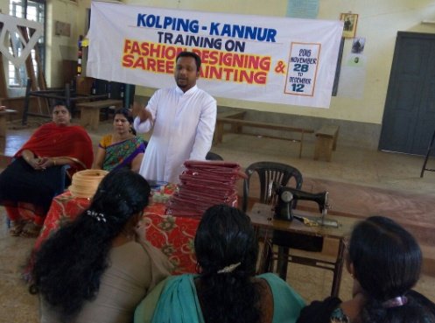

k. Functional Kolping Groups
KAIROS have promoted around 82 Kolping groups in different parishes in which there are a total of 1087 members. They have savings and credit programs. Among them there are 12 men groups 60 women groups and 5 mixed groups
l. Educational Support
Educational support has been extended to 10 professional and vocational students.
3. KERALA LABOUR MOVEMENT
The work of KLM is becoming more and more active in the Diocese of Kannur. Awareness programs are the major requirement of all units. Every year new office bearers are elected in many units. Different forums like tailors, domestic workers, shops and other establishment workers, etc. are registered.
So far we have enrolled 125 tailors, 300 domestic workers, 187 artisans and other skilled workers and 700 workers in shops & other commercial establishments. 81 members from tailoring sector are enrolled online. 400 members remitted their subscription in Swawalamban.
May Day was observed in a very attractive manner at Payangadi New Bus stand premises. The President of KAIROS, Most Rev. Dr. Alex Vadakumthala, inaugurated the program. Many trade union leaders were felicitated.
As a new step we organized at Kanhirangad an awareness class for migrant workers. 25 migrant workers from Orissa attended the meeting. We are taking steps to enroll them in the Kshemanidhi.

4. NATURAL RESOURCE MANAGEMENT
1. Environmental protection & Conservation
Natural Resource Management (NRM) is one of the major and important areas of intervention of KAIROS and has a very good track record in the implementation of watershed development projects and other related programs. As of now, KAIROS is implementing five Watershed Development Programs under Western Ghat Development Programs (WGDP): Naduvil GP, Alakkode GP, Cherupuzha GP, East Eleri GP and West Eleri GP. The activities carried out during the reporting year are manifold and can be classified under three heads: a) Activities for soil and water conservation; b) Livelihood support and c) Capacity building of the watershed community.
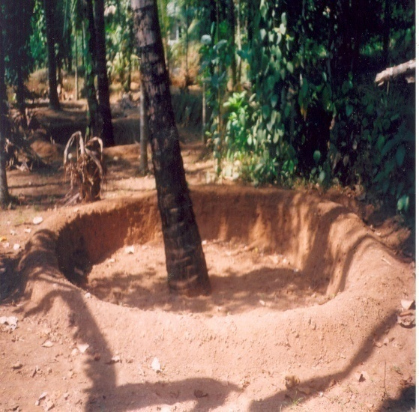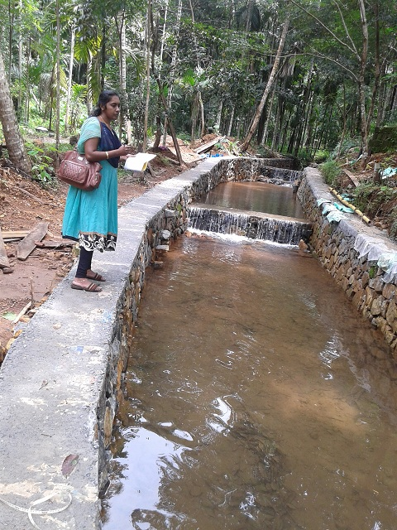
All these three categories of programs led to sustainable Natural Resource Management which helped the people to understand the need of conservation of natural resources. The conservation activities preserved the farm land from deterioration. Empowerment and sustainable livelihood of the landless and vulnerable sections like tribal community and women are also taken care of as part of the program.
In this financial year the achievements are: construction of contour bund 11500 M², retaining wall 650 RM, Agrological measures 4500 RM, Loose bolder check dam 32, Weir 2, Live fencing 300 RM. are going on as per plans.

2. ‘Puzhaye Ariyan’ at Mangara

The program was arranged on the bank of Chapparappadavu river near Mangara. The students of St. Thomas UP School and the villagers, were actively involved in the program. It is intended to impart knowledge on the life and survival of a river. They were told that care should be taken to protect the river at every point. The river banks should be protected from erosion and for which 500 mangrove saplings were planted on either sides of the river by the participants. The program was very interesting and the group spent one full day in studying about the river and its life. The local development committee (the Village Development Council) has taken the lead role. It was a great experience for both the program organizers and the participants. 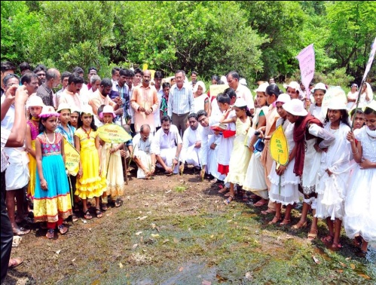

- Water Protection Through Conservation

The greatest threat which is going to be faced by the coming generation will be the scarcity of drinking water. Water is the rare gift of God and it should not be wasted. To preserve water and make the abundant availability of water, KAIROS organized an awareness class about water protection with the support of likeminded organizations. The seminar was held at Bishop’s house. The famous environmentalist Dr. Sunny George handled different sessions. In the second phase of the program our Director Rev. Dr. Jilson Panakkal handled the sessions.

4. Environment day
On the 5th June, the Environment Day was observed by KAIROS at Mangara; the group members and many officials participated. The main event was planting 500 “Lakshmi Tharu”, an indigenous plant which is used in the treatment of cancer. An orientation class was also arranged for the participants on the need of planting Lakshmi tharu in the house premises. Mr. Saji Othara, the GP President of Chapparappatavu was the chief guest. Associate Director of KAIROS Fr. Shaiju Peter was also present.

5. Income Generation Programs -KSBCDC
KAIROS particularly promotes Income Generation Programs (IGP) for economically weaker sections of the community which are expected to be supplemental to their well being. Financial support was arranged with the financial institutions especially from KSBCDC through linkages and lobbying. Finance also arranged with SHGs and their Federations, which channelize funds from the savings of its members. Every possible support and follow-ups are extended to individual entrepreneur by the expertise of KAIROS staff. In the reporting year, around 225 individual entrepreneurs selected from 48 groups started IGPs. Some of the schemes are internet café, goods auto, poultry farm, garments unit etc. An amount of Rs. 50, 00,000/- was channelized from KSBCDC which was used to support the deserving candidates/families to start IGPs. The launching of the program was inaugurated by the Hon’ble Minister for Ports Shri. Kadannappally Ramachandran in a colorful function presided over by our VG Msgr. Devasi Erathara.
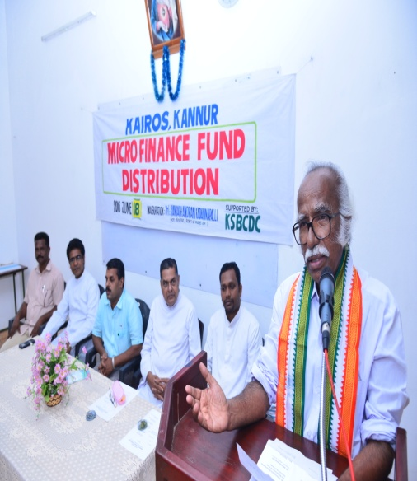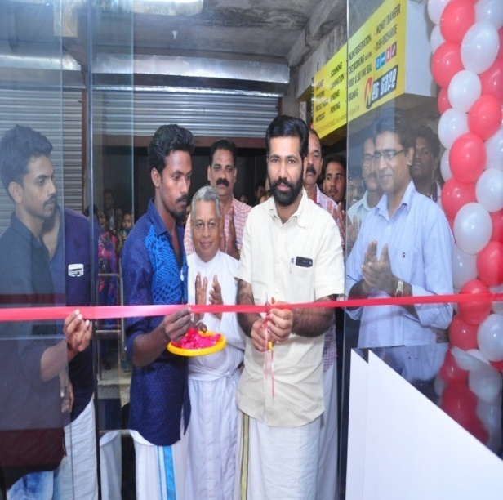

6. Asakiranam programe
Asakiranam program is a protection campaign initiated by KAIROS for cancer patients supported by Caritas India. Smt. Sreemathy Teacher, M P from Kannur launched the diocesan level program in a function presided over by Msgr. Clarence Paliath; Mr. K. V. Sumesh, the Kannur Zilla Panchayat President being the Chief Guest. The cancer awareness class was conducted by Shri. D. Krishna Nath Pai, President, Malabar Cancer Care Society, Kannur.
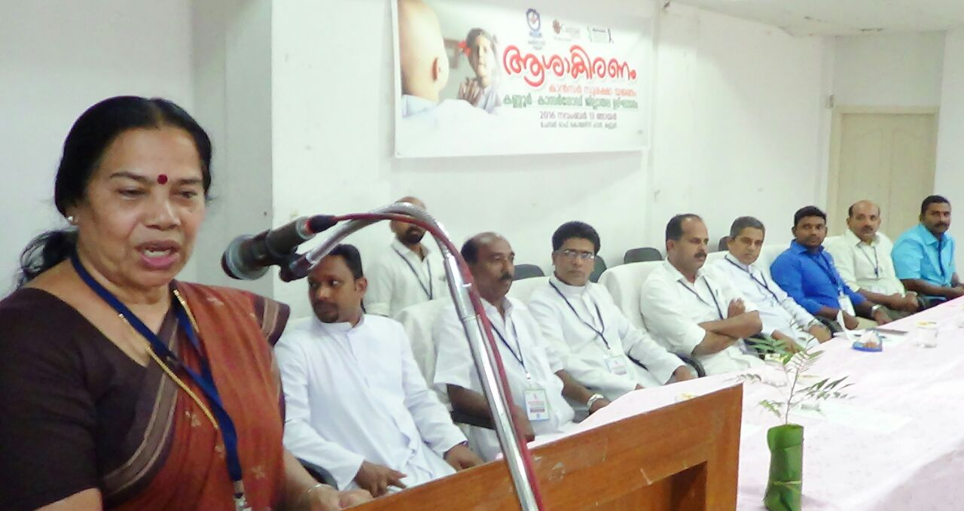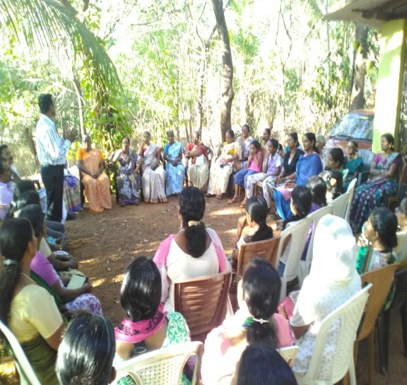
7. Jalanidhi Programes
"Jalanidhi" envisages a sustainable and people managed water supply system in Rural Areas. KAIROS, as Supporting Organization has implemented two JALANIDHI-projects in Kannur District – one in Kolayad Grama Panchayath (GP) and the other in Irikkur Grama Panchayat. The project also promotes total sanitation, ground water recharging, and GP level strengthening through technical and general trainings to the project stakeholders. Jalanidhi is seen more a demand driven than need based.
Project in Irrikkur was inaugurated by Shri. P J Joseph the then Honorable Minister of Irrigation in a function presided over by K. C. Joseph, the then minister for Rural Development. The Kolayad Jalanidhi project is also completed and awaiting inauguration.
8. Health Promotion Programs
- Axshya :
TB awreness program was conducting in the Iritty Block with the support of Catholic Health Association of India (CHAI). The main focuss area is Iritty block. House hold survey, awareness classes, sputum collection and transaction etc. were done during the period. Nine sign boards were also errected at differrent centres of the Block Punchayat. 5500 households were surveyed, 20 awreness classes were held, 35 referal slips were issued, 15 samples of sputum were collected and transported to the designated laborataries.

- AIDS DAY Program :
On International AIDS day, KAIROS has organized two programs – one a street play and the other nutrition kit distribution and family get together. The street play was staged in four higher secondary and Schools and old bus stand Kannur. The message of the street play was mainly prevention of and community support for the HIV infected and affected.
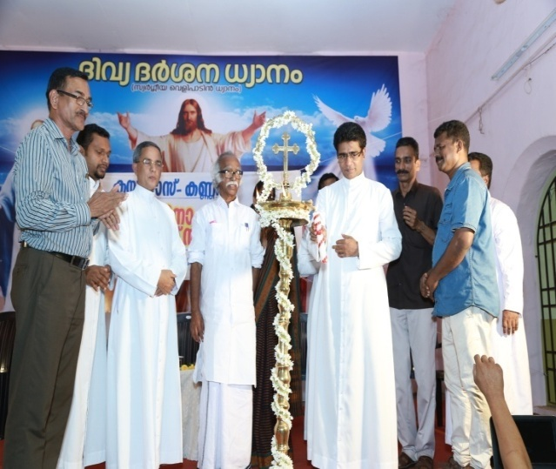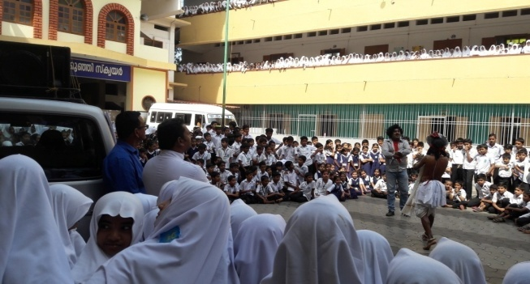
Nutrition kit worth Rs. 1000/- was distributed among 110 families. The family get together program was also arranged, which was inaugurated by Hon’ble Minister Shri. Kadannappally Ramachandran. At the end of inauguaration session, cultural programmes were also staged by the participants. Travelling allowance to the patients who are taking ART was also disbursed from the meeting.

9.Women’s Day Programme
International Women’s day was observed on the 8th March at Thaliparamba Town Square. As part of the celebration vipanana mela was also organized and products worth Rs. 35,000/- were sold. In the afternoon a women’s get together also took place. The get-together was presided over by Very Rev. Fr. Devassy Erathara, the Vicar General of Diocese of Kannur. The function was inaugurated by Smt. P.K. Shyamala Teacher, the Chair Person of Anthur Municipality; Smt. P. P. Latha, President, Thaliparamba Block Panchayat being the Chief Guest. Mrs. Shibi Bernard felicitated the gathering. Prizes for the toppers in the exhibition was distributed by Smt. Rajani Remanand, the Standing Committee Chairperson of Taliparamba Muncipality.

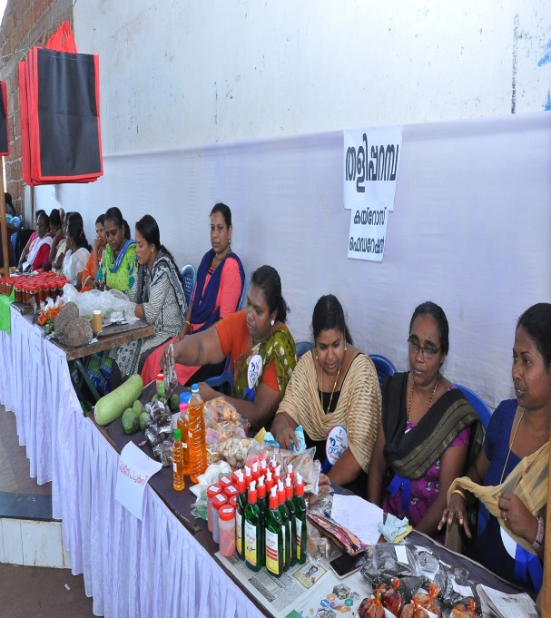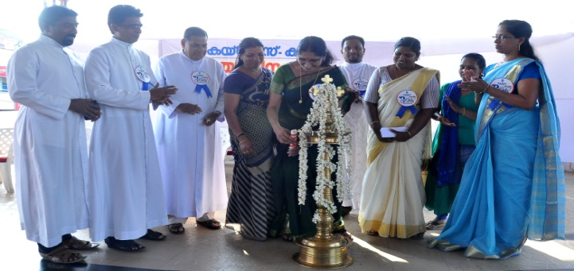

10. Special Group formation
We took special interest this reporting year to form special groups of people who are left behind from the mainstream organizational activities like SHGs. We conducted a special convention of the widows groups at Poovam, Embett, Bekkalam, Vellikkal, Pattuvam & Pilatahra. So far we are able to form six spinsters groups and seven senior citizens groups.
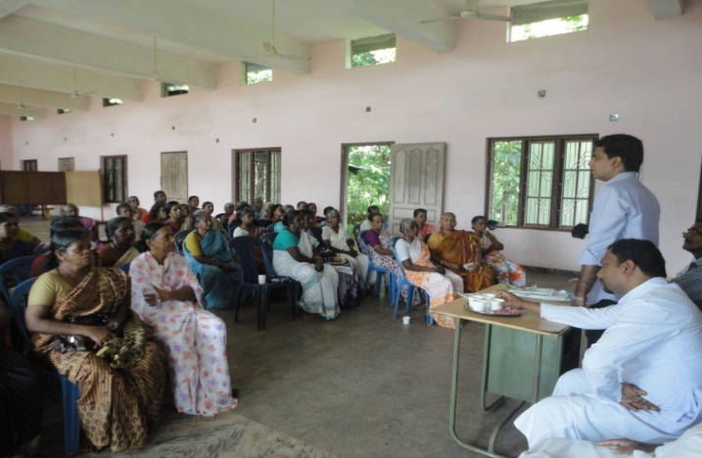
11. Micro finance
There was no access to the poor for the resources that may support them to overcome their poverty. If the less privileged are equipped properly with the financial resource centers as well as the knowledge base accessible to them, they will produce extra ordinary results. To establish linkages to such resource centers, one of the ways adopted by KAIROS was the formation and the strengthening of people’s groups in the form of SHGs and their federations at grass root level. In this endeavor, KAIROS has gone a long way and now there are 420 groups and 6 federations of such groups. They began to save their little earnings and achieved several targets of financial promotional activities. The money they saved has been redistributed among the members, through which are able to overcome their difficult situations.
12. Social Impact Study
The District Collector of Kannur has selected our organization to conduct a Social Impact Study regarding the construction of a new road and widening of the existing one for the Coast Guard Academy at Irinavu. Our team studied could successfully complete the Social Impact Study and submitted the report to the District Collector in time. The report was well appreciated and as a result another assignment was given to us. It is to conduct a Social Impact Study about the construction of a S.V. Station to Gas Authority of India Limited (GAIL) at Tripangottur village in Thalassery Taluk.
Now we are also selected as the agency to conduct the Social Impact Study for the land acquisition for the development of the road from Francis Road Junction to Mangav Road Junction in Kozhicode District.
13. Cashless Digital Kannur & Kasaragod
In the event of the demonetization policy of the central government in order to reduce the circulation of paper currency and to encourage the common people to adapt to digital transactions, in collaboration with the Waynad Social Service society (WSSS) we conducted seminars at Nadakkav and Cherooppa in Kasaragod district and Mangara and Aripambra in Kannur district. About 170 villagers benefited from these awareness programs.

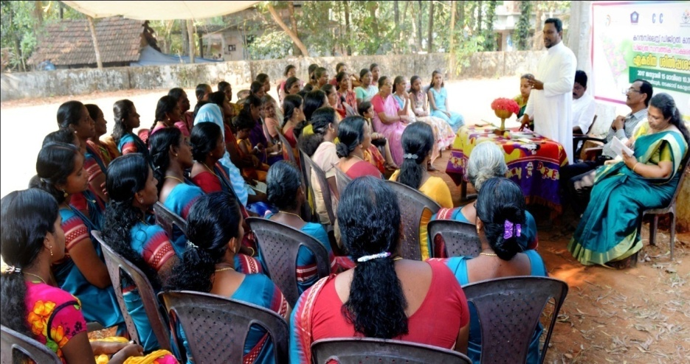
Conclusion
The reporting we gave prime importance to the capacity building of the people that could empower members to take up the grievances and serious issues that negatively affect the development of the people and the communities at the grass roots level. The capacity building programs and the other awareness generation programs organized and conducted by KAIROS have been instrumental for the development the people. We are also committed to continue our capacity building programs in the coming years also.
People must have the opportunity to decide and determine their priorities. Most of the groups are taking up their destiny and are prepared to go further. They also seek to gain control and access to the resources. Economic empowerment is one of the means to empower the marginalized and the less privileged. Enhancing women’s economic productivity at the grass root level is an important strategy for improving the welfare of hundreds of households living below the poverty line. Our effort is to make the COBs capable of accessing the resourceful institutions that are dedicated and committed to the cause of the poor.
We thankfully remember the agencies and institutions which were instrumental for the achievements of KAIROS during the reporting period. If it is not for their support and guidance, these achievements were not possible and we expect the similar support, cooperation and guidance from those partners for the coming years also.
A few words of gratitude for the whole team of KAIROS for having been instrumental for the transition taken place among the poor and marginalized, the new horizon of achievements in the socio economic development, and for the creation of the future generation who are ready to work for their own development.

Rev. Dr. Jilson Panakkal
Director - KAIROS

